How to Add a Reseller Number Via the customer’s LIV + App
If you forget to enter your reseller number, follow these steps (or walk the customer through these steps) to add a system to your Pro Dashboard

- From the Device homepage, select the system you need to add your reseller number to. In this case we want to add the system “Firepit”.
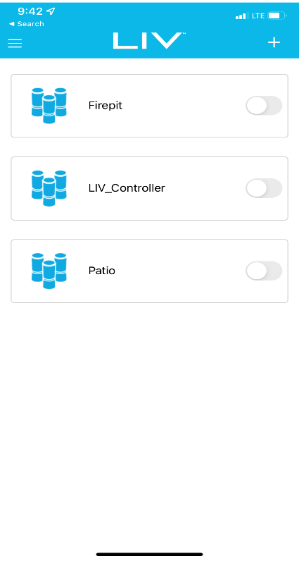

- Next click the 3 dots in the upper righthand corner of the app screen.
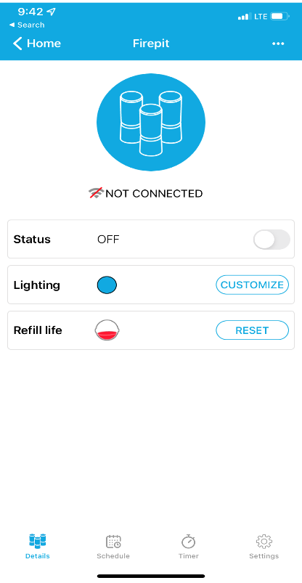

- Select the “Update Franchise” option below.
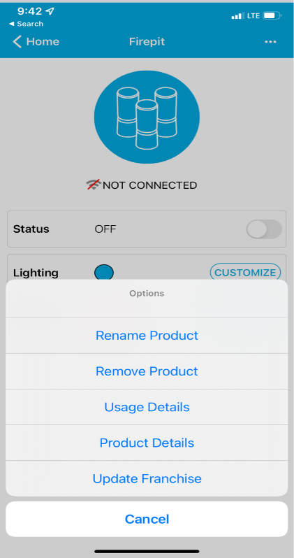

- Enter your Thermacell Reseller number. The device will now be added to your dashboard.
